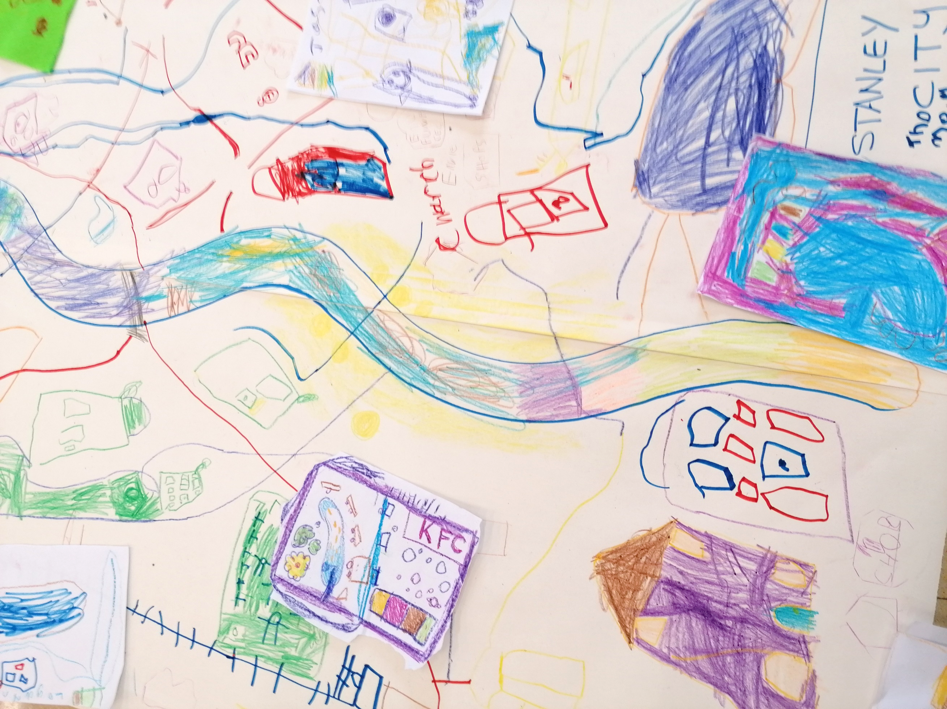

By Paul Carney
www.paulcarneyarts.com
Primary Art, Craft & Design Progression

Progression in Art & Design
Progression in art and design is an enormously difficult and complex process that has been widely studies and researched for over a hundred years. This webpage attempts to set out how you might do it. I’ll try to be as concise as I can be:

To summarise progression:
- You need to identify pupil’s individual starting points in key art areas of skills, knowledge, and creativity.
- List the skills you will teach year on year so that they gradually increase in difficulty over time and provide opportunities for pupils to learn and properly embed them.
- Outline a map of the essential knowledge you want pupils to know and remember year on year. This should not only be the names and factual details of art and artists, but also the meanings behind why they made the art and how it connects to other art.
- Stimulate creative growth, imagination, applying visual language, exploration, and inquisitiveness through the construction of projects and activities that nurture personal choice.
- Measure the progress children are making through simple assessment metrics embedded into positive, but constructive dialogue.
- Identify end points in your curriculum - learning goals, attitudes, and behaviours that pupils will demonstrate at key times.

To teach art and design, deliver SKILLS & KNOWLEDGE through CREATIVE projects that improve pupils own PERSONAL DEVELOPMENT over time.

These are my four areas of progression in art:

- Technical proficiency of skills - in multiple, self-selected pictorial repertoires, not only ones selected by a teacher as being the most appropriate.
- Understanding and applying knowledge - for both artistic intentions and as critical enjoyment. All knowledge taught relates to a bigger key concept that underpins a deeper understanding of the subject.
- Creativity - as series of activities, exercises and projects that develop the ability to think and act with purpose and originality. These are the activities and lessons that you teach, the alchemy of art practice.
- Personal development - the growth of the reflective, thinking artist. This develops and grows over lifetimes, not key stages, but the journey begins here. Educational stages (or years) should regularly check this progress and report back to students on their progress.

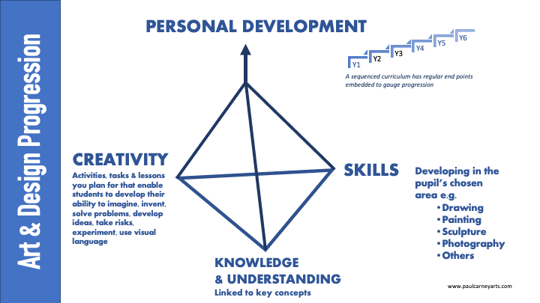
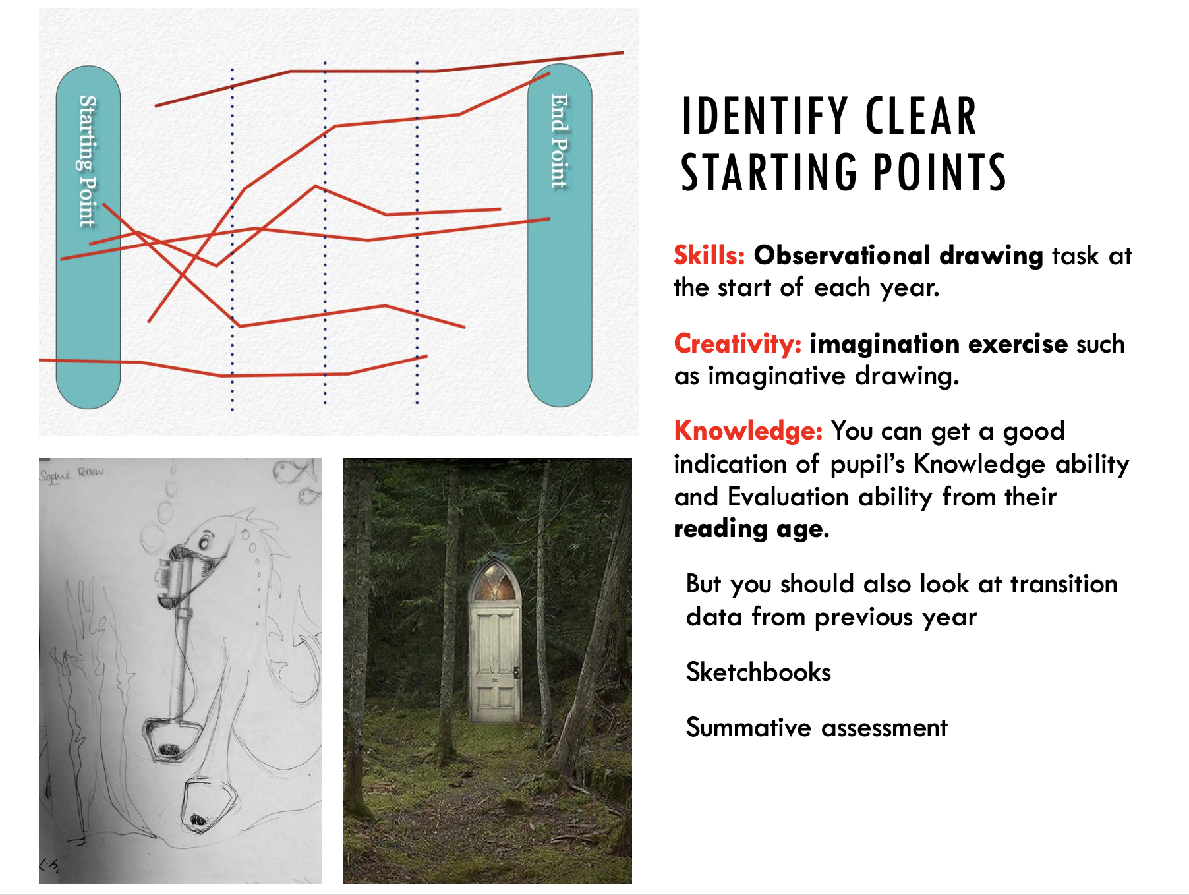
EYFS Art, Craft & Design Knowledge & Skills Progression
 |  | Main Progression targets that sequence year on year
Skills  Become proficient in drawing, painting, sculpture and other art, craft and design techniques  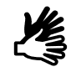 | Drawing | Skill & Control | Pupils develop their control and confidence when drawing using a range of materials. Pupils draw forms using the formal elements of lines & simple shapes such as circles, squares and triangles. Pupils learn to tonally shade areas and shapes as neatly and carefully as they can.
 |  | Medium | Pupils learn to draw in different ways to create different effects.
 |  | Purpose | Pupils draw things they like and learn to draw for pleasure and relaxation. Pupils draw from imagination and observation. They record ideas, thoughts, feelings and draw for narrative reasons.
 | Painting & Mixed Media | Skill & Control | Learn how to hold and control a paintbrush. They learn to blend colours in a palette or on the painting surface. They learn how to look after brushes and equipment.
 |  | Techniques | Use a range of painting tools to experiment with mark making; brushes, sponges, tissue, fabric, string etc.
 |  | Formal Elements | Colour: They learn fundamental colour mixing using primary colours. They play with colours, experimenting to ‘discover’ new colours.  They try to mix colours to match images from paintings or books etc.  Tone/Form: Pupils learn that colours can be made darker or lighter by adding black or white or by adding more water/pigment.  Pattern & Texture: They paint patterns & add things to paint to make textures such as sand, grit, salt.  Line/Shape: They concentrate hard to paint shapes, lines and edges neatly.
 | Design | Pupils should make something they have imagined or invented, such as a toy or a creature. This might be drawn initially then modelled in plasticine for example.
 | Craft | Use simple wax resist using crayons and ink is used to make pictures. Art is made by cutting, sewing, gluing and forming fabrics. Textiles are decorated with simple appliqué techniques such as beads, sequins, coloured threads, lace, found or reclaimed materials. Collage is used to select and cut colours, shapes, textures and images from a range of sources to suit ideas and purposes.
 | 3D Sculpture, Printmaking, Digital, Clay etc. | Printing Pupils make simple printing blocks from soft materials they have cut, shaped, or moulded.  Digital: Children take photographs with digital cameras, learning to focus & position what they see then apply filters to the results.  3D sculpture Pupils learn to create Form by cutting, forming, and joining familiar 3D shapes such as packaging, cartons or boxes into desired effects. Simple shapes and forms are made from pliable materials such as modelling clay, foam or wire for example.
Creativity  Explore ideas, invent, imagine, problem solve | Develop & share ideas | Learn how ideas change, grow and develop as work is produced.
 | Experiences, Imagination | Create art from personal experiences and imagination.
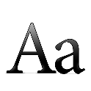  Knowledge  Learn great Artists, Craft & Design Learn how artists use formal elements | Artists, Craftspeople, Designers | Investigate works of art and try to explain how the artwork makes them feel, highlighting areas that interest them.
 | Formal Elements | Pupils should orally describe their work & learn the meaning of the words colour, line, tone, shape, texture and pattern.
Reflection  (Which leads to personal development)  Evaluate and Analyse own & others work | Identify similarities and differences to others’ work | Has opportunities to make creative decisions about the content of their work, select appropriate media to work with and making choices about outcomes.  Develop skills in orally describing their thoughts, ideas and intentions about their work.
 | Make choices & decisions | Compare their art to significant works of art recognising what is the same and what is different.

Year 1 Art, Craft & Design Knowledge & Skills Progression
 |  | Main Progression targets that sequence year on year
Skills  Become proficient in drawing, painting, sculpture and other art, craft, and design techniques | Drawing | Skill & Control | Pupils develop their ability to use and apply the formal elements by increasing their control of line & using simple 2D geometric shapes when drawing. They explore the concept of light & dark, learning how to create both values and controlling them to make tones. They practice shading tones neatly & accurately. Pupils learn how to control the pressure of their drawing materials.
 |  | Medium | Pupils are shown a range of drawing media including graphite sticks, charcoal, crayons, coloured pencils. They learn the differences and similarities between. Pupils try out new ways of making lines/marks to describe a range of surfaces, textures, and forms.
 |  | Purpose | Draw from imagination & observation.
 | Painting & Mixed Media | Skill & Control | They know different types of paint and the properties of each such as poster paint, powdered paint, block paint. Develop skills in measuring and mixing paint, they blend colours in palettes and on the paper and develop ability in applying paint skilfully. Paint on 3D surfaces such as models and textures using thicker paints taking care to ensure a good standard of finish.
 |  | Techniques | They know and have used different types of painting surfaces such as cartridge paper, card, brown paper, coloured papers, fabrics, and textured surfaces and say which is suitable for a give task.
 |  | Formal Elements | Colour: Pupil’s use colours imaginatively learning that colour can be used to express their thoughts and feelings.  Tone/Form: Pupils further develop their ability to make colours darker and lighter and understanding of how this affects form.  Pattern & Texture: They paint patterns & add things to paint to make textures such as sand, grit, salt.  Shape/Line: They paint thick and thin lines using different brushes, big and small shapes in a range of pure and mixed colours.
 | Design | Pupils should design & make something they have imagined or invented. This might be realising a drawing and then modelling it in three dimensions.
 | Craft | Collage is used to select and cut colours, shapes, textures, and images from a range of sources to suit ideas and purposes. Images are developed with more complexity and appliqué techniques such as beads, sequins, coloured threads, lace, found or reclaimed materials are used.
 | Other Materials | Printing Pupils learn different methods of printing such as mono printing, block printing, relief printing or by etching into soft materials. They print using simple materials, card, string, foam, textured materials and paper, clay, polyprinting etc.  Digital: They learn to take photos with digital cameras taking care to frame the shot to capture the detail they want. They use simple software to edit and manipulate photos.  3D sculpture Pupils cut, form, tear, join and shape a range of materials (such as modelling clay, card, plastic, wire, found and natural) to create Forms to make things they have designed, invented, or seen.
Creativity  Explore ideas, invent, imagine, problem solve | Develop & share ideas | This may be coming up with an idea linked to a theme or topic they are studying.
 | Experiences, Imagination | Drawing events and things that have happened to them, things they know and love or imagining far away, imagined places.
Knowledge  Learn great Artists, Craft & Design Learn how artists use formal elements | Artists, Craftspeople, Designers | Study famous works of a c & d, learning how and when they were made. They describe the content and the feelings & emotions conveyed by the work.
 | Formal Elements | Learn the meaning of the words colour, line, tone, shapes, textures and patterns and begin using them in their art. Recognise when they are using formal elements and describe how they are using them.
Reflection  (Which leads to personal development)  Evaluate and Analyse own & others work | Identify similarities and differences to others’ work | Has opportunities to make creative decisions about the content of their work, select appropriate media to work with and making choices about outcomes.  Develop skills in orally describing their thoughts, ideas and intentions about their work. They form opinions about the process of their work saying what went well & how they might improve it.
 | Make choices & decisions | Compare their art to appropriate works of art recognising what is the same and what is different.

Year 2 Art, Craft & Design Knowledge & Skills Progression
 |  | Main Progression targets that build year on year
Skills  Become proficient in drawing, painting, sculpture and other art, craft and design techniques | Drawing | Skill & Control | Greater skill & control is evident when using the formal elements to draw, e.g., using simple lines & geometric shapes to create forms. Control pressure when using drawing implements to create lighter or darker tones and marks, such as when sketching. Increasingly able to shade areas neatly without spaces & gaps. Identify & draw detail, texture, pattern.
 |  | Medium | Learn to use pencils hard and soft, crayons, felt-tips, charcoal and chalk, digital means, inks and other materials such as wire, wool, straws, cotton buds, feathers, sticky tape to create expressive drawings.
 |  | Purpose | Pupils have developed a sense of what they like drawing and have the opportunity to draw these, learning to improve their style from a range of sources including observation and secondary sources.
 | Painting & Mixed Media | Skill & Control | Develop brush control & learn to use different types of paint and painting surfaces, identifying different paintbrushes, and painting equipment. Pupils learn to paint neatly and carefully, without leaving gaps or messy edges. Learn to measure & mix the paint needed & apply paint sensitively with control.
 |  | Techniques | Experiment with painting on a range of 2D surfaces such as cartridge paper, card, brown paper, coloured papers, fabrics, and textured surfaces. Learn to use different techniques to create effects such as spattering, stippling, dripping, pouring etc. to paint expressively.
 |  | Formal Elements | Colour: Develop colour mixing to make finer variations in secondary colours.  Tone/Form: Pupils learn why light colours appear to be to us and dark objects look further away, then explore this in their art.  Pattern & Texture: Create original patterns & make textures.  Shape/Line: Understand the importance of outlines & paint more sophisticated shapes.
 | Design | Pupils design & make complex forms from imagination & invention in two or three dimensions, such as inventing for problem solving or creating imaginary worlds.
 | Craft | Art is made in a range of experimental craft forms such as weaving, sewing, etchings, painting onto fabrics, wire, jewellery or using coloured modelling clay etc. Textiles are decorated with more complexity and appliqué techniques such as beads, sequins, coloured threads, lace, found materials are used. Collage is used to select and cut colours, shapes, textures, and images from a range of sources to suit ideas and purposes.
 | Other Materials | Printing Pupils use printing (mono printing, block printing, relief printing etc.) to create artwork that might be related to bigger topics and themes or to explore patterns for example. They use simple motif printing blocks to create and print complex patterns with mathematical and visual precision.  Digital: Learn how to use a digital camera to frame the shot to suit their purpose and can edit them using simple software for cropping. Learn painting software to edit and manipulate photos to create more complex images.  3D sculpture Cut, form, tear, join and shape a range of materials (such as modelling clay, card, plastic, wire, found and natural) to create Forms & make things they have designed, invented or seen & can modify & correct things with greater skill. Make simple plans for making, deciding which tasks need to be done first, allowing for drying and completion time, they know when to get advice.

Creativity  Explore ideas, invent, imagine, problem solve | Develop & share ideas | Work should be continued over longer periods of time. Pupils should have opportunities to discriminate between choices and express their ideas & thoughts about the type of art they want to make.
 | Experiences, Imagination | Study the work of artists and cultures and use elements of it to influence their own work. Have opportunities to work from imagination, such as inventing or creating imaginary things and places.
Knowledge  Learn great Artists, Craft & Design Learn how artists use formal elements | Artists, Craftspeople, Designers | Study significant works of art craft & design, learning how and when they were made. They describe the content, feelings & emotions conveyed by the work to a more competent level.
 | Formal Elements | Pupils learn how to create more complex art using the properties of line, tone, colour, texture, pattern, shape and form. Recognise when they are using these qualities and describe their intentions.
Reflection  (Which leads to personal development)  Evaluate and Analyse own & others work | Identify similarities and differences to others’ work | Pupils develop skills in verbally describing their thoughts, ideas and intentions about their work. Talk about how they could improve their work and learn that it is normal to feel anxious about the outcomes. They offer critical advice to others understanding that all artists do this and give confidence and praise.
 | Make choices & decisions | Pupils should describe their work and the work of others, describing the formal elements of colour, line, shapes, textures and patterns. They should develop skills in orally describing their thoughts, ideas and intentions.

Year 3 Art, Craft & Design Knowledge & Skills Progression
 |  | Main Progression targets that sequence year on year
Skills  Become proficient in drawing, painting, sculpture and other art, craft and design techniques |  | Skill & Control | Identify and draw the 2D & 3D geometric shapes in nature and the world around them. Pupils can more effectively control drawing media to create dark and light tones. They further practice shading tones with few gaps, that are neat to the edges. They can more effectively blend shading and can rub out rough edges or refine them. Pupils develop their confidence making marks & lines to describe a wide range of surfaces, textures & forms.
 |  | Medium | Pupils work in a range of drawing media including graphite sticks, charcoal, crayons, coloured pencils, felt pens, biro, drawing ink and pastels. They know the differences and similarities between these materials and select which one is most suitable for the task they need.
 |  | Purpose | Record experiences such as trips and experiences or to describe sequences of events. Describe, copy, and imagine how things might have looked in the past or in another place or culture. Draw things they can see (from nature, their environment, still life or from photos they have taken)
 | Painting & Mixed Media | Skill & Control | Pupils are developing their painting skills increasing control, & precision when painting detail, lines and edges of shapes.  They know and have used different types of paint and painting surfaces, they can identify different paintbrushes and painting equipment, understand the various purposes they have.  Pupils study how other artists’ paint, applying elements of this to their work.
 |  | Techniques | Learn how to paint with expression by combining traditional painting methods with unorthodox and unusual tools and techniques (such as rags, sticks, fabrics, sponges etc.)
 |  | Formal Elements | Colour: Pupil’s mix secondary and tertiary colours to paint with and use colours, textures, lines and shapes imaginatively and appropriately to express ideas. Tone/Form: Learn how depth is created by varying the tones or colours, such as in skies and landscapes and how much more interesting this makes the painting. Line/Shape: Painting with line for expression and to define detail. Pattern/Texture: Create more complex patterns and textures.
 | Design | Design and make art for different purposes, such as stage sets, fashion, cars, inventions, puppets, toys, books, games etc. and see clear links to how this works in the creative industries.
 | Craft | Pupils gain experience in using collage as an art form, they might explore crafts such as embroidery, sewing, knitting, felt, weaving, jewellery, batik, modelling etc.
 | Other Materials | Printing Pupils use printing (mono printing, block printing, relief printing etc.) to create artwork that might be related to bigger topics and themes or to explore patterns for example. They use simple motif printing blocks to create and print complex patterns with mathematical and visual precision.  3D sculpture They should design and make Forms in 3 dimensions, using card, wire, paper, found objects, clay or modelling materials, understanding how to finish and present their work to a good standard.  Digital: Pupils have opportunities to make art using digital means; drawing & painting programmes, vector drawing, photo manipulation.
Creativity  Explore ideas, invent, imagine, problem solve | Sketchbooks | Sketchbooks are used to practice and try out ideas & techniques. They make records of the world around them, their ideas, thoughts, feelings and discoveries.
 | Experiences, Imagination | They might make art from things they can see from observation; their environment, photographs etc. then translate them into new materials.
 | Develop Ideas | Make art for expression, imagination, and pleasure. Work from memory or imagination to reimagine what they know.
Knowledge  (Factual)  Learn great Artists, Craft & Design Learn how artists use formal elements | Learn about artists, craftspeople, architects, & designers | Study significant works of art, craft, design or architecture and give personal oral opinions about it. How has the artist produced this work? What was the background to the art? Who made, where were they from? Why was it made? Make copies of small areas of the artist’s work to study their techniques, colour, tone, textures and patterns used etc. Look at art for pleasure and purpose, talk about why they like it, developing their use of the language of art (formal elements).
Reflection  (Which leads to personal development)  Evaluate and Analyse own & others work | Increasing understanding of purpose & intention for art | Pupils should verbally describe their work and the work of others, describing the formal elements of colour, line, shapes, textures and patterns. They should develop skills in orally describing their thoughts, ideas and intentions.
 | Awareness of choices & decisions | Uses evaluation to understand what they need to do to improve and that all artists do this. Pupils talk about how they could improve their work and learn that it is normal to feel anxious about the outcomes. They offer advice, confidence and praise to others. Uses evaluation to understand what they need to do to improve and that all artists do this.

Year 4 Art, Craft & Design Knowledge & Skills Progression
 |  | Main Progression targets that sequence year on year
Skills  Become proficient in drawing, painting, sculpture and other art, craft and design techniques | Drawing | Skill & Control | Develop ability to accurately identify and render 2D & 3D geometric shapes when drawing from observation or second-hand sources, becoming aware of proportion, scale, and order. Make progress in controlling line & shading with graphite, chalks, and charcoal to describe shape, form and light and shade. Practice drawing quick, light lines (sketching) & more deliberate, measured lines. Learn different styles of drawing; Graphic (cartoon, graffiti, caricatures etc.) Realistic (portrait, still life etc.) Abstract (fine art, emotions)
 |  | Medium | Make drawings and experiment through mark making using pencils hard and soft, crayons, felt-tips, charcoal and chalk, digital means, inks and other materials such as wire, wool, straws, cotton buds, feathers, sticky tape.
 |  | Purpose | Visualise their thoughts, feelings & memories or to express experiences they have had. Describe, copy and imagine other places, cultures and peoples past and present. Draw things they can see and (from nature, their environment, still life or photos they have taken)
 | Painting & Mixed Media | Skill & Control | Use paint with sensitivity & control, more accurately applying appropriate amounts of paint to the surface. Use different types of paint such as poster paint, powder, watercolour, or acrylic for example. Know when to use these paints & name some of their properties.
 |  | Techniques | Experiment with colour, texture, line, shape & composition to create express purpose, mood and feelings when painting.
 |  | Formal Elements | Colour: Pupils learn how colour has light and dark values and how colour can be used to make colours lighter or darker, creating more vibrant paintings such as those produced by the Impressionists.  Tone/Form: Pupils paint awareness of how tone can make paintings more realistic or more expressive, learning to manipulate light and shade for dramatic effect. Line/Shape: Use line with greater confidence to highlight form and shape. Pattern/Texture: Use pattern & texture for desired effects and decoration or more expressive, learning to manipulate light and shade for dramatic effect.
 | Design | Design and make art for different purposes, such as stage sets, fashion, cars, inventions, puppets, toys, books, games etc. and see clear links to how this works in the creative industries.
 | Craft | Pupils gain experience in using collage as an art form, they might explore crafts such as embroidery, sewing, knitting, felt, weaving, jewellery, batik, modelling etc.
 | Other Materials | Printing Pupils use printing (mono printing, block printing, relief printing etc.) to create both individual images and repeat patterns. They use simple motif printing blocks to create and print complex patterns with mathematical and visual precision.  3D sculpture Design and make Forms in 3 dimensions, using card, wire, paper, found objects, clay or modelling materials, understanding how to finish and present their work to a good standard. They are more confident at modelling materials, they work safely and sensibly, persevering when the work is challenging.  Digital: Pupils have opportunities to make art using digital means; drawing & painting programmes, vector drawing, photo manipulation.
Creativity  Explore ideas, invent, imagine, problem solve | Sketchbooks | Sketchbooks are used to practice and try out ideas & techniques. They make records of the world around them, their ideas, thoughts, feelings and discoveries.so their sketchbook becomes a very personal space.
 | Experiences, Imagination | They might make art from things they can see from observation; their environment, photographs etc. then translate them into new materials.
 | Develop Ideas | Make art for expression, imagination, and pleasure. Develop initial ideas into final work adapting work as it progresses.
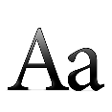  Knowledge  (Factual)  Learn great Artists, Craft & Design Learn how artists use formal elements | Learn about artists, craftspeople, architects, & designers | Study significant works of art, craft, design and architecture and give more complex personal oral opinions about it. How has the artist produced this work? What was the background to the art? Who made, where were they from? Why was it made? Make copies of small areas of the artist’s work to study their techniques, colour, tone, textures and patterns used etc. Study how other artists’ make art, including the work of other peoples and cultures, past and present. Look at art for pleasure and purpose, talk about why they like it, developing their use of the language of art (formal elements).
Reflection  (Which leads to personal development)  Evaluate and Analyse own & others work | Increasing understanding of purpose & intention for art | Orally describe their work and the work of others, describing the formal elements of colour, line,
 | Awareness of choices & decisions | Uses evaluation to understand what they need to do to improve and that all artists do this. Pupils talk about how they could improve their work and learn that it is normal to feel anxious about the outcomes. They offer advice, confidence and praise to others. Uses evaluation to understand what they need to improve and that all artists do this.

Year 5 Art, Craft & Design Knowledge & Skills Progression
 |  | Main Progression targets that sequence year on year
Skills  Become proficient in drawing, painting, sculpture and other art, craft and design techniques | Drawing | Skill & Control | Can draw with an increasingly confident awareness of the 2D and 3D geometric forms that comprise forms and objects.  Can draw lines, shapes, and forms neatly and evenly with more confidence, blending tones from light to dark smoothly. They control the amount of force and pressure when drawing to understand the difference between sketching and rendering more deliberate marks. Awareness of various mark making techniques for purpose & intention.
 |  | Medium | Independently select appropriate media for expression and purpose, taking risks and experimenting with drawing media that are harder to control, such as pieces of card, straws, sticks, and perishable items to create more expression with drawing.
 |  | Purpose | Draw for a range of purposes, thinking, designing, creating, realising, imagining. Learn that we all draw differently, and that realism is only one form of drawing. Find and know artists’ drawings they like, appreciate and admire to influence their own drawing style.
 | Painting & Mixed Media | Skill & Control | Pupils know and care for painting equipment. Develop skills to paint neatly and carefully, without leaving gaps or messy edges, yet they paint in a more creative style when the painting demands. They should learn how to control the amount of paint they need to use and/or use water to preserve finer details.
 |  | Techniques | They know different types of paint and when to use them, such as what paint to use for painting models and which to use for landscapes. They experiment with expressive painting techniques such as brush use, applying & combining media, adding things to paint etc.
 |  | Formal Elements | Colour: Develops ability to control colour when painting; for blending, reducing hue and improving the translucency of colour. Knows colour relationships such as complimentary colours, harmonious colours (colours next to each other on the colour wheel). At this stage they should mix secondary and tertiary colours, being able to control the amounts for purpose. Tone/ Form: Pupils learn how to represent form with increasing sophistication, learning that darker and lighter colours can be added to create tints and shades instead of black and white. Line/Shape: Uses line or shape to create original compositions. Pattern Texture: Uses pattern & texture for purposeful effect.
 | Design | Have opportunities to design and make art for different purposes, such as buildings, magazines, logos, digital media, textiles, fashion, and interior design and see clear links to how this works in the creative industries.
 | Craft | Pupils gain experience in using collage as an art form, they might explore crafts such as embroidery, sewing, knitting, felt, weaving, jewellery, batik, modelling etc.
 | Other Materials | Printing Pupils develop mono printing, block printing, relief printing etc. to create artwork that might be singular images or patterns. They use more complex printing blocks with mathematical and visual precision.  3D Sculpture: Design and make more complex Forms in 3 dimensions, using a range of modelling materials, understanding how to finish work to a good standard.  Digital: Produce digital art using computers, drawing & painting programmes, vector drawing & photo manipulation for example.
Creativity  Explore ideas, invent, imagine, problem solve | Sketchbooks | Pupils experiment with techniques in sketchbooks to see what works and what doesn’t. They label these experiments for their own learning and record keeping. Sketchbooks are used to practice and try out ideas & techniques. Record observations & research of artists and themes. Use a sketchbook for pleasure, recording, ideas & expression so their sketchbook becomes a very personal space.
 | Experiences, Imagination | Take risks when trying out materials, investigate and explore the properties of materials.
 | Develop Ideas | Produce original, unique art in response to similar starting points with increasing autonomy over choice and decision making.
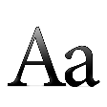  Knowledge  (Factual)  Learn great Artists, Craft & Design Learn how artists use formal elements | Learn about artists, craftspeople, architects, & designers | Study significant works of art using the following method:  - Content – Describe the art. Social, historical factors affect the work.  - Process – When & how made? What materials & techniques are used?  - Formal elements – line, tone, colour, shape, form, comp, pattern, texture.  - Mood – what emotions does the work convey?  Applying: Make studies of artist’s work to learn the techniques & processes used. Use some of what they have learned from artist’s studies to produce original work.
Reflection  (Which leads to personal development)  Evaluate and Analyse own & others work | Increasing understanding of purpose & intention for art | Pupils should try to fairly appraise their own work and understand how to improve it, accepting criticism of other pupils. Know that the creative process often leaves us with a lot of doubt, anxiety and uncertainty.
 | Awareness of choices & decisions | Make careful and considerate judgments about own & others work without comparing their own work to that of others. Uses evaluation to understand what they need to do to improve & that all artists do this.

Year 6 Art, Craft & Design Knowledge & Skills Progression
 |  | Main Progression targets that sequence year on year
Skills  Become proficient in drawing, painting, sculpture and other art, craft and design techniques | Drawing | Skill & Control | Draw with increasing confidence developing their own personal style. They know how & when to sketch and when to render more confident line, using a developing ability to skilfully control the outcomes. Learn how to describe form from several different light sources. Know and apply very basic one-point perspective.
 |  | Medium | Pupils work in a range of media with increasing confidence (pencils hard and soft, crayons, felt-tips, charcoal and chalk, digital means, inks and other materials such as wire, wool, straws, cotton buds, feathers, sticky tape for example). They have greater choice over what materials they should use, working to own strengths and personal tastes.
 |  | Purpose | Learn styles of drawing & how it is used; 1. graphic (cartoon, graffiti, fashion etc.) 2. realistic (portrait, still life etc.) 3. technical (architecture, product design, plans, diagrams) 4. Illustration (books, magazines) 5. Abstract 6. Sculptural (3D, wire, card, architectural models) 7. Digital (using computers, tablets, film) other materials.
 | Painting & Mixed Media | Skill & Control | Pupils should have the skill now to control paint to work in different ways; precise and accurate when needed yet loose and instinctive when required. Pupil’s painting should show a more confident ability to create 3D form, depth and distance using colour and tone. They should know different types of paint media and when to use them, they should be familiar with different papers and surfaces to paint on and be able to name them.
 |  | Techniques | Paints from observation, describing different surfaces and textures forms using tone, line, texture, and colour to express mood and feeling. Pupils should be introduced to a range of different artists’ work and painting styles. They are more confident at articulating which styles they prefer and why they like them.
 |  | Formal Elements | Colour: Colours should be mixed with care and sensitivity to show feeling and ideas. At this stage they should confidently mix secondary and tertiary colours, being able to control these to suit their own purpose. Understand colour relationships such as complimentary & harmonious colours. Tone/Form: They can control paint to make things appear lighter and further away or with darker, more intense hues to bring them closer, such as when painting landscape. When painting 3D models and forms, they should be aware of the need to prepare the surface for paint & apply paint carefully, thinking about effects & detail. Line/Shape: Uses line with confidence to represent own ideas and compositions. Pattern/Texture: Understands how to apply pattern and texture with confidence to decorate or embellish paintings.
 | Design | Increasingly challenging opportunities to design and make art for different purposes, such as buildings, magazines, logos, digital media, textiles, fashion, and interior design for example. To solve design problems, to invent, create or imagine and see clear links to how this works in the creative industries.
 | Craft | Pupils could gain experience in using collage as an art form; they might explore crafts such as embroidery, sewing, appliqué knitting, felt, weaving, jewellery, batik, pattern, modelling etc.
 | Other Materials | Printing Pupils develop more complex mono printing, block printing, relief printing etc. to create artwork that might be singular images or patterns. They use more complex printing blocks with mathematical and visual precision.  3D sculpture Design and make more complex Forms in 3 dimensions, using card, wire, paper, found objects, clay or modelling materials, understanding how to finish and present their work to a good standard.  Digital: Produce more complex digital art using computers, drawing & painting programmes, vector drawing & photo manipulation for example.
Creativity  Explore ideas, invent, imagine, problem solve | Sketchbooks | Experiment with techniques in sketchbooks to see what works and what doesn’t. They label these experiments for their own learning and record keeping. Sketchbooks are used to practice and try out ideas & techniques. Record observations and research of artists and themes. Use a sketchbook for a range of purposes, pleasure, thoughts, ideas & expression so their sketchbook becomes a very personal space.
 | Experiences, Imagination | Use materials with increasing spontaneity and confidence, experimenting and taking risks over choices of media
 | Develop Ideas | Make art from nature, their environment, still life or from photos they have taken. Make art from their aspirations for their future and the future of others, their fears, hopes and dreams for themselves and the world they live in.
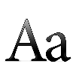  Knowledge  (Factual)  Learn great Artists, Craft & Design Learn how artists use formal elements | Learn about artists, craftspeople, architects, & designers | Study significant works of art using the following method:  - Content – Describe the art. What social, historical factors affect the work?  - Process – When & how was the work made? What materials & techniques are used?  - Formal elements – line, tone, colour, shape, form, composition, pattern, texture.  - Mood – what emotions does the work convey?  Applying: Make studies of artist’s work to learn the techniques & processes used. Use some of what they have learned from their artist’s studies to produce original work.
Reflection  (Which leads to personal development)  Evaluate and Analyse own & others work | Increasing understanding of art purpose & intention | They should develop greater knowledge about the role of art in society, the many vocations that can be gained through art and its importance to the UK economy.
 | Awareness of choices & decisions | Understand that the making process is very difficult and so pupils should know that they should not be too self-critical or compare their work to others at their own expense. They should try to fairly appraise their own work and others work and understand how to improve it, accepting criticism of other pupils. They should know that most artists struggle with this and that it is a vital part of the art process.

How progression works
It is common for primary schools to create a long-term topic overview of the topics they will teach throughout the year. This is fine, but you cannot meander through art domains, jumping from one art medium to the next if you want children to build their skills. They must have time to gradually increase the level of difficulty in selected areas, to properly embed and learn the skills they are learning.
By colour coding each art medium in this plan, I can see when and where we are covering drawing, painting, printing etc. I can see where the gaps are and where my coverage is strongest and weakest. I know for example, that I’m only teaching painting once in Year 2, 4 and 5 and it may be that I want to teach this further.
However, we need to ensure we are sequencing threads through our planning so that skills build up properly. You would therefore need to identify the progression skills target you want to teach, allow time for the pupils to practice and repeat it over time, then teach the corresponding skill the following year in order to sequentially improve.
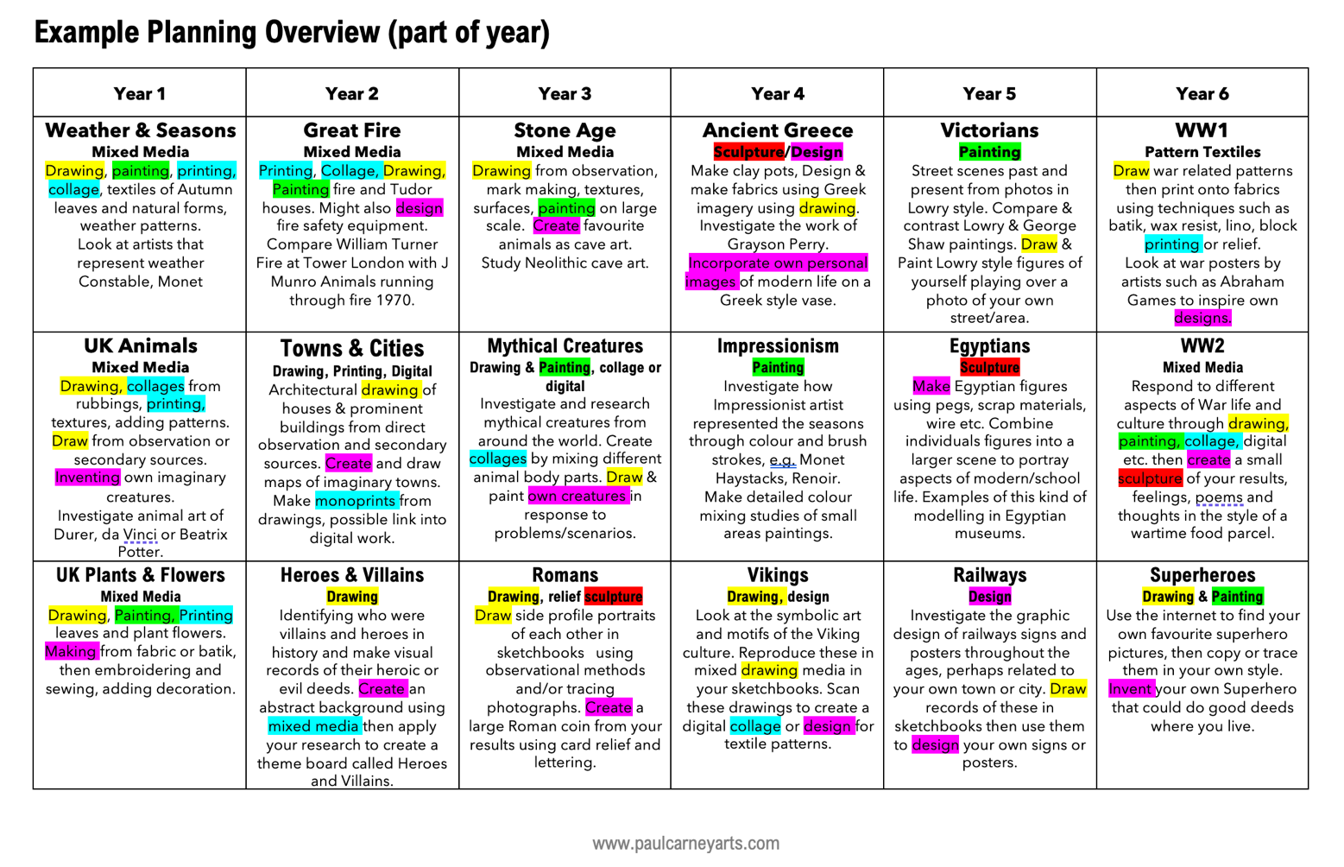
Year 3 Drawing Skill & Control: Identify and draw the 2D & 3D geometric shapes in nature and the world around them. Pupils can more effectively control drawing media to create dark and light tones. They further practice shading tones with few gaps, that are neat to the edges. They can more effectively blend shading and can rub out rough edges or refine them. Pupils develop their confidence making marks & lines to describe a wide range of surfaces, textures & forms.

Year 2 Drawing Skill & Control: Greater skill & control is evident when using the formal elements to draw, e.g., using simple lines & geometric shapes to create forms. Control pressure when using drawing implements to create lighter or darker tones and marks, such as when sketching. Increasingly able to shade areas neatly without spaces & gaps. Identify & draw detail, texture, pattern.
Year 1 Drawing Skill & Control: Pupils develop their ability to use and apply the formal elements by increasing their control of line & using simple 2D geometric shapes when drawing. They explore the concept of light & dark, learning how to create both values and controlling them to make tones. They practice shading tones neatly & accurately. Pupils learn how to control the pressure of their drawing materials.

Assessing Progress – What Makes an Artist?
When Ofsted come calling, they will want to talk to your pupils about their own progress. This assessment system is designed to promote children’s ability to understand their progress and be able to discuss it.
This progression document tries to develop the creative approaches described by Professor Bill Lucas and Ellen Spencer in their book Teaching Creative Thinking. In the book, the authors outline five essential creative habits of mind: imagination, inquisitive, discipline, collaboration and persistence. Fifteen further sub-qualities strengthen and enhance these five habits such as questioning, reflecting and investigating.
In my What Makes an Artist document I have tried to encapsulate the essence of their outstanding work and combine it with the National Curriculum objectives and NSEAD guidance to create a set of easily digested artistic traits that promote best practice in the subject.
What Makes an Artist is an AfL pupil-centred assessment and progression tracking system. Each pupil places a copy in their sketchbooks or folders and uses it throughout the year to record their achievements in art and design. This might be done once per term in circle time, or as and when the teacher requires.
The method of recording achievement is deliberately left ambiguous so that schools can use their own preferred system—stars, points, comments, meeting, exceeding, developing etc.
The intention of this method is for the teacher to guide the students into recognising when they have achieved these objectives themselves, rather than the teacher doing it for them. In this way, students take ownership of their progress and can see easily what they are doing well and what they need to do to improve.
Progression builds from year 1 to year 6 and focusses on the key qualities that encompass the ideal traits of successful practicing artists, so that students can be confident they are developing all the essential characteristics of being a successful artist themselves.

Key Stage 1 progression
Writing will be limited at this stage so it might be that stickers or stamps are used each time a progression competency has been demonstrated.
Learn new skills
Indicate how the pupil has become more proficient in drawing, painting, sculpture and other art, craft and design techniques. Pupils might list the skills they have learned and simply write whether they were exceeding, developing, meeting next to them and the date; Drawing = Meeting 12th Jan for example.
Gain new knowledge
Learn about artists, craft makers and designers or techniques they have studied.

Discuss
Be able to describe the differences and similarities between different practices and disciplines, making links to their own work. This can be a verbal or written progression target, so it might be that the teacher awards marks or points for this (according to your system) based on observations they have made.

Investigate
How artists use and apply the formal elements of art & design, find out things about art and artists at home, in groups or on their own.
Imagine
What level of skills have they gained in designing, developing ideas, producing creative work or exploring their ideas and imagination? How often do they get the opportunity to create imaginatively?

Look
Indicate how well they have observed, studied and looked at new things. Show that they have recorded their experiences.

Lower Key Stage 2 progression
Pupils should continue to build on the skills they have been developing in Key Stage 1, but now there are two new targets: enjoying art and making mistakes. As pupils age, they begin to become more anxious and self-conscious about their work and these targets help to overcome that. Artists are always anxious about the work they are making; this is part of the creative process. How can we help each other to overcome this?
Note that these two icons do not feature in the teacher planning progression guide. This is because these are holistic qualities that will emerge at random times of the programme. The teacher might highlight when these have occurred, but it is hoped that, in time children will take ownership of where these have occurred themselves.

Enjoy Art
Enjoying art is more important than the quality of outcome because we will improve more if we are motivated than if we constantly strive for perfection. Learn to be kind to yourself about the art you do.

Learn from Mistakes
Remind pupils that we all make mistakes and we need to learn from them. This is not an excuse to deliberately be careless, but rather not to let mistakes defeat us.

Upper Key Stage 2 progression
Pupils should continue to build on the skills they have been developing in Key Stage 1 and Lower Key Stage 2, but now there are three new targets; designed to make children confident, successful artists who can think for themselves and develop their own ideas for work.
Note that these three icons do not feature in the teacher planning progression guide. This is because these are holistic qualities that will emerge at random times of the programme. The teacher might highlight when these have occurred, but it is hoped that in time children will take ownership of where these have occurred themselves.

Take Risks
All children gravitate to doing the things they are best at, but they will become better artists by trying new things, being adventurous, exploring new ideas and materials and taking risks with their work even though it may fail.

Be Independent
Artists must be independent and develop resilience, yet at the same time learn how to work with others respectfully. This means producing work without asking for help all the time and developing good communication skills.

Make decisions
Give pupils opportunities to make their own choices about the work they do. Allow them to decide what materials to use for example or on what scale.

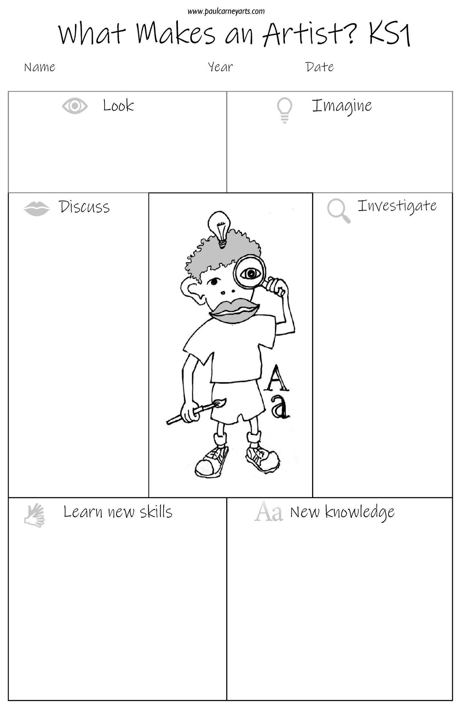
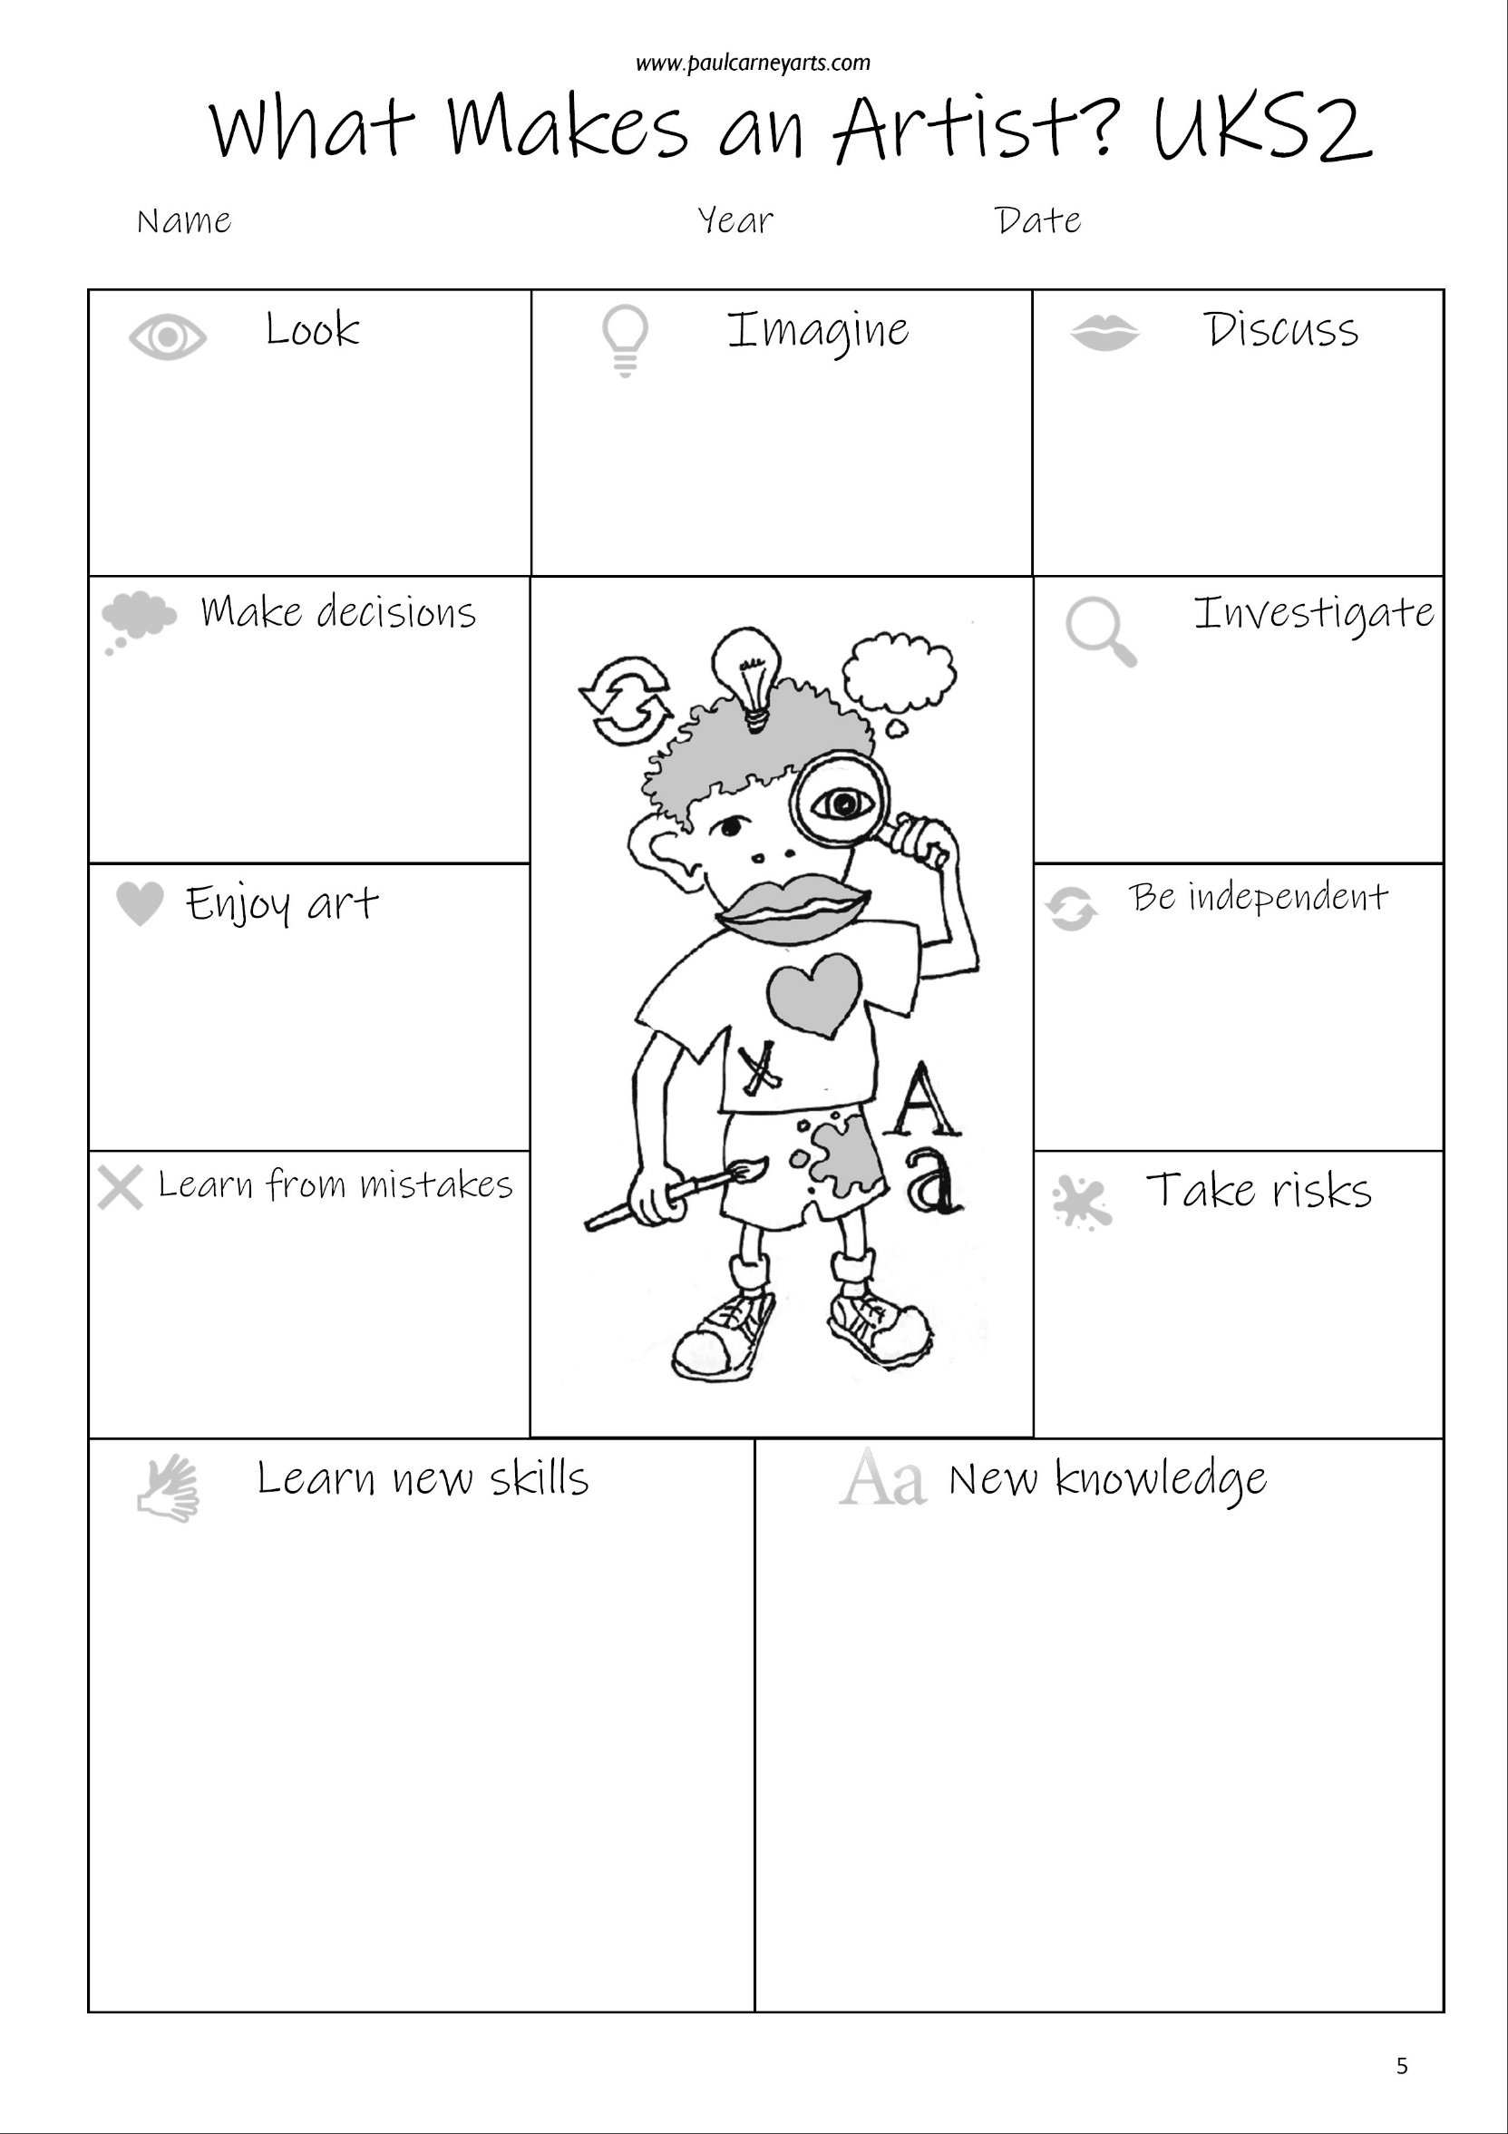

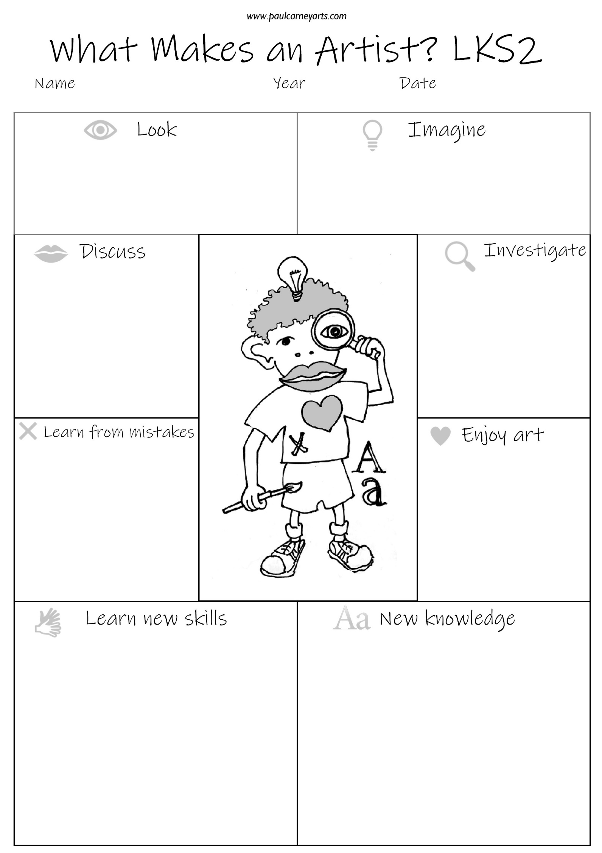

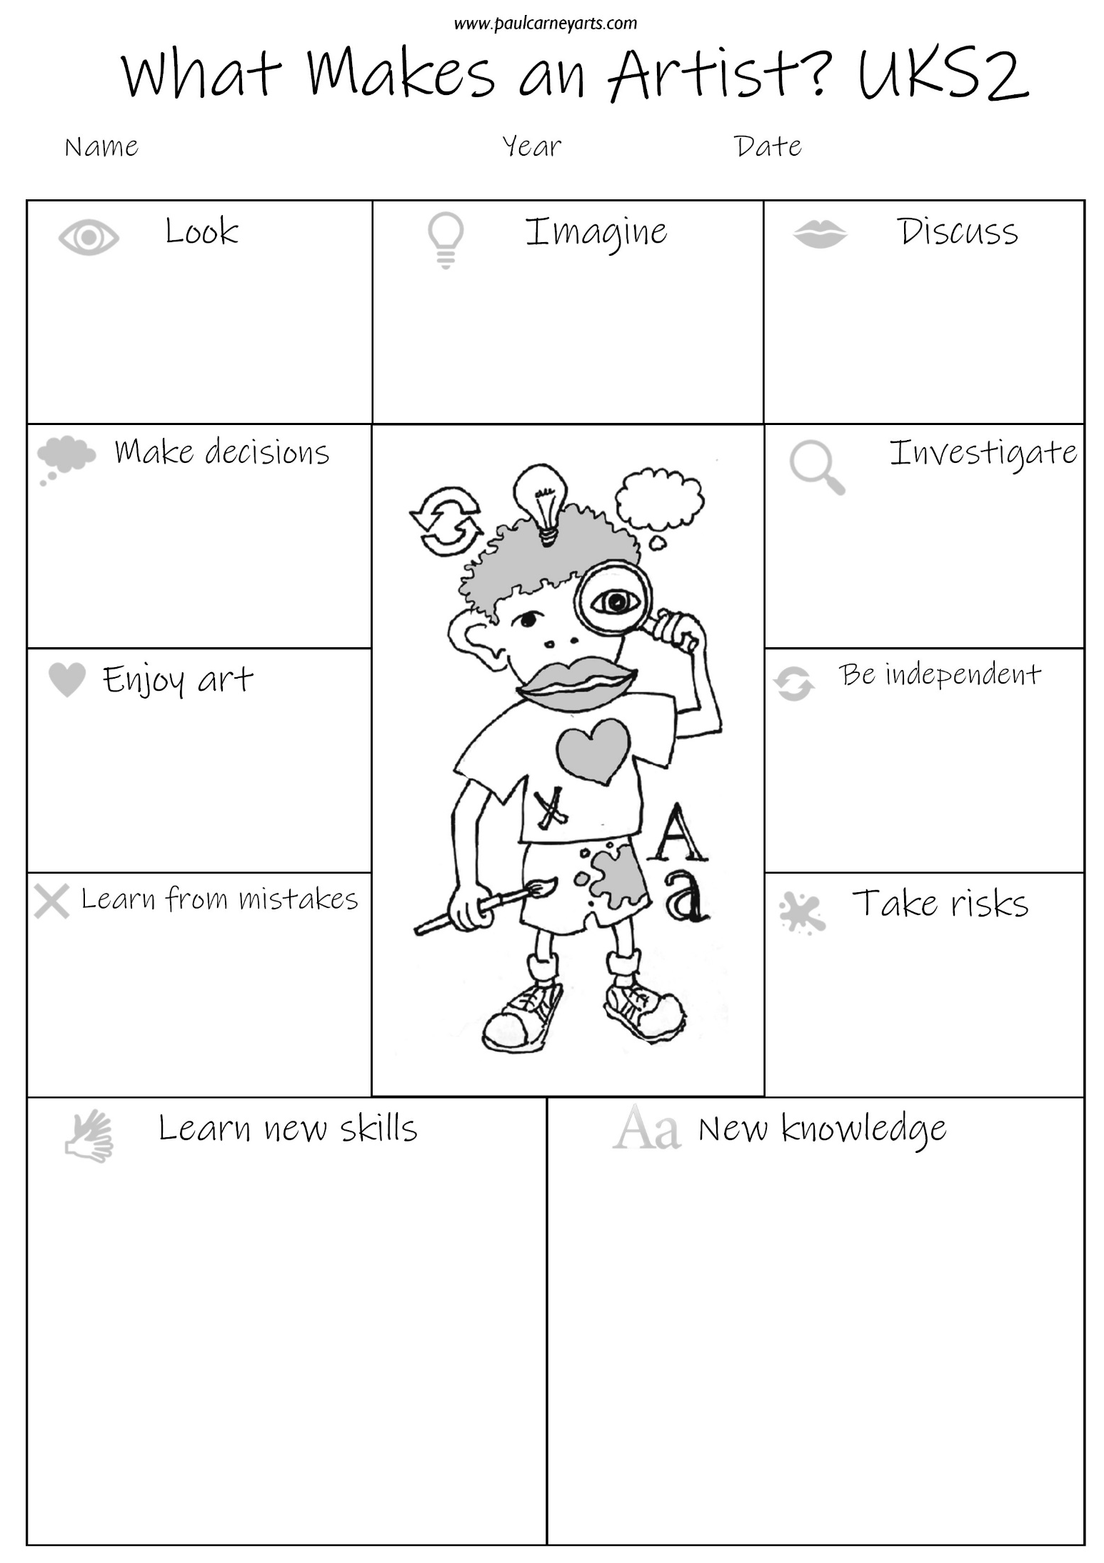
Assessment Capabilities
Creative capabilities are expectations and look for’s, that you think children should know and do at certain educational points. Keeping with the UK educational framework we might then draw up expectations for art and design at key educational phases.
By end of EYFS
- Drawing - Pupils should be able to draw basic lines, circles, squares, x shapes and triangles and construct more complex forms using these, e.g. flowers, people, animals. They should have practiced shading techniques through simple colouring exercises and experimented making different marks using a range of tools and techniques.
- Painting - Pupils should have had experience of painting. They should know how to hold a paintbrush comfortably, be able to mix and apply basic colours to make secondary colours. They should have experienced painting lines, dots, patterns and shapes, trying to paint neatly to edges.
- Media - They should have experienced a range of craft activities such as modelling with clay, cutting with scissors, simple printing and creating things using fabrics and textures. They should have made digital art using cameras and editing apps.
- Ideas - Pupils should have made art from observation and using their imagination.
- Knowledge - Pupils should have seen the work of significant artists and discussed their personal opinions of them.
- Evaluation - They should have talked about how art makes them feel and the emotions it evokes.

By end of KS1
- Drawing - Pupils should be able to draw basic lines and shapes with increasing confidence to create more complex forms. They should have drawn and made marks using a range of media and surfaces, drawn from observation and imagination and developed their ability to shade and colour neatly & evenly.
- Painting – there should be an increased ability to control brushes and paint to render ideas & observations. They should have used different paints and surfaces, be able to mix primary & secondary colours confidently and use different painting techniques such as stippling, dripping, spattering etc.
- Media - there should be a well-developed ability to apply formal elements in their work using drawing, painting, craft and mixed media. Pupils should have
designed & invented complex forms to solve problems, experienced craft processes such as weaving, sewing, cutting, fabrics, wire, clay and collage.
- Ideas – Should understand how to develop ideas over time. Express ideas about things they want to make. Use imagination to invent and create. Select aspects of significant art to incorporate in own work.
- Knowledge – Learn how artists use formal elements in work to create effects, ideas and feelings. Study significant works of art.
- Evaluation – Identify similarities and differences in own and others work. Make choices and decisions. Give and receive constructive praise and criticism.
By end of lower KS2
- Drawing - Further developed skills in drawing using 2D and 3D shapes, becoming aware of proportion, scale and order of drawn forms. Develop shading using a range of media. Learned sketching techniques, mark making and drawing in different media. Draw for different purposes and reasons.
- Painting – Increasing control using different painting techniques, painting on different surfaces exploring textures, pattern, colour, line, shape and form. Create ideas, thoughts, moods and feelings through paint.
- Media – Design & make for purpose, experience a range of craft mediums such as collage, embroidery, sewing, weaving, felt. Have learned simple printing techniques and used blocks to make repeat patterns. Created 3D sculptures and forms in a range of materials. Created digital images and edited these using appropriate apps.
- Ideas – Have used sketchbooks to record observations, thoughts, ideas, research & explore. Used art to express ideas & feelings, made art for pleasure and to develop ideas.
- Knowledge – Given opinions of art using a more complex vocabulary related to the formal elements of art. Studied how significant artists work both in the past and today.
- Evaluation – Used evaluation in the classroom to understand what they need to do to improve. Learned how to advise others and receive constructive criticism.

Upon leaving KS2
- Pupils should be able to draw complex forms using 2D and 3D shapes to help them. They should have a grasp of basic one-point perspective and learned how to model forms using shading, light and tone. They should have drawn using a range of mark making techniques in a range of media, making their own choices and decisions when drawing. There should be an awareness of different styles of drawing for different purposes and reasons.
- Painting – Pupils should paint with greater confidence and control, understanding how to mix and blend primary & secondary colours, create tone and textures and apply paint sensitively for purpose. They understand how to use and apply the formal elements when painting.
- Media – Pupils should have designed and made art for different purposes. They should have explored craft techniques and developed their skill in cutting, joining and forming when working in a range of craft materials. They will have developed their printing ability by printing geometric patterns, made 3D sculptures, and created digital art using photography and editing apps.
- Ideas – Pupils will be familiar with using a sketchbook to record thoughts, ideas, feelings, research, investigations and explorations in media. They will be more confident at taking risks, working independently and mistake making. They will have worked from their imagination, from observation and used art to express their thoughts and feelings.
- Knowledge – Pupils will have studied significant art in some depth and be aware of a basic chronological development of art over time. They will know the content, process, form, mood technique of deconstructing art. They will be aware of the different purposes of art in society and as a creative occupation.
- Evaluation – Pupils will be sensitive to the inner difficulty of the creative process and be able to use discussion and feedback to build confidence in themselves and others.

